Method 1: IMAGE RECONSTRUCTION

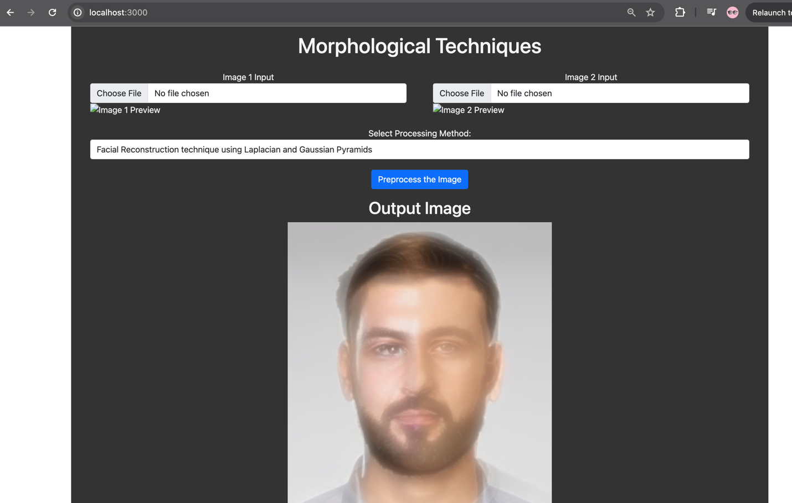

METHOD 2: WEIGHTED AVERAGE MORPHING

METHOD 3: LINEAR INTERPOLATION

METHOD 4: AFFLINE TRANFORM

METHOD 5: FEATURE BASED MORPHING

